**SQL Data Analysis Case Study**

This project is for the **Taste Of The World Café**, a restaurant that has diverse menu offerings and serves generous portions.

**Project Assignment**

The taste of the world cage debuted a new menu at the start of the year. I have seen asked as a data analyst to see which menu items are doing well/not well and what the top customers like best.

**Objectives**

1. Explore the menu_items table to get an idea of the data that is on the current menu.
2. Explore the order_details table to get an idea of the data that has been collected.
3. Use both tables to understand how customers are reacting and recommending based on the analysis for the new menu.

**Objective 1) Analysis Item Table**

**-- View the Menu Item Table**

select count(restaurant_db.menu_items.menu_item_id) from restaurant_db.menu_items;

**-- What is the most expensive item in the menu?**

select max(restaurant_db.menu_items.price) from restaurant_db.menu_items;

**-- What is the least expensive item in the menu?**

select min(restaurant_db.menu_items.price) from restaurant_db.menu_items;

**-- Show list prices in order from max to min or min to max**

select restaurant_db.menu_items.price from restaurant_db.menu_items order by price desc;

select restaurant_db.menu_items.price from restaurant_db.menu_items order by price asc;

**-- How meny Italian dishes are on the menu?**

select count(*) from restaurant_db.menu_items where restaurant_db.menu_items.category = 'Italian';

**-- What are the least and most expensive dishes on the menu?**

select * from restaurant_db.menu_items where restaurant_db.menu_items.category = 'Italian' order by price asc;

select * from restaurant_db.menu_items where restaurant_db.menu_items.category = 'Italian' order by price desc;

**-- How meny dishes are on each category?**

select restaurant_db.menu_items.category,count(restaurant_db.menu_items.menu_item_id) as menu_item from restaurant_db.menu_items group by restaurant_db.menu_items.category;

**-- What is the average dish price in each category?**

select restaurant_db.menu_items.category,count(restaurant_db.menu_items.menu_item_id) as menu_item, avg(restaurant_db.menu_items.price) as average_price from restaurant_db.menu_items group by restaurant_db.menu_items.category;

**Objective 2) Analyse Order table**

**-- View order table**

SELECT * FROM restaurant_db.order_details;

**-- Find date table**

select * from restaurant_db.order_details order by restaurant_db.order_details.order_date;

**-- Find the date range of the table**

select min(restaurant_db.order_details.order_date) as min_order_date, max(restaurant_db.order_details.order_date) as max_order_date from restaurant_db.order_details;

**-- How meny orders were made?**

select restaurant_db.order_details.order_id, count(restaurant_db.order_details.order_details_id) from restaurant_db.order_details group by restaurant_db.order_details.order_id;

select count(distinct restaurant_db.order_details.order_id) as total from restaurant_db.order_details;

**-- Which order has the most number of items?**

select order_details.order_id, count(order_details.item_id) as item from order_details group by order_id order by item desc;

**-- Show number of orders has more than twelve item.**

select order_details.order_id, count(order_details.item_id) as item from order_details group by order_id having item > 12;

**-- How meny orders have more than 12 item?**

select count(*) from (select order_details.order_id, count(order_details.item_id) as item from order_details group by order_id having item > 12) as num_order;

**Objective 3) Analysis Customer behaviour**

**-- Combine the menu item and Order detail table into a single table.**

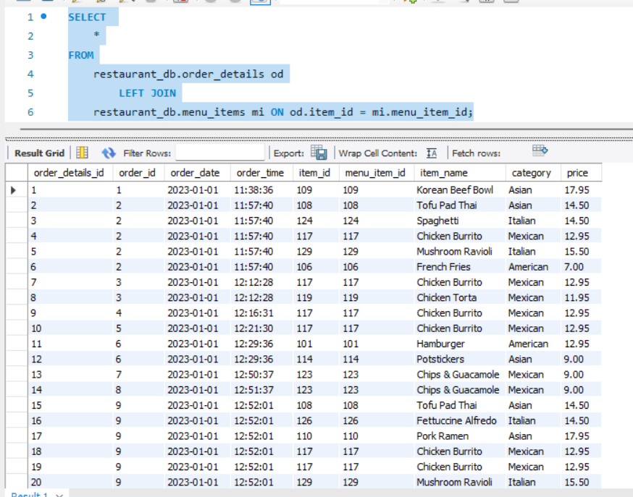

**-- What were the least and most popular order item? what items were they in?**

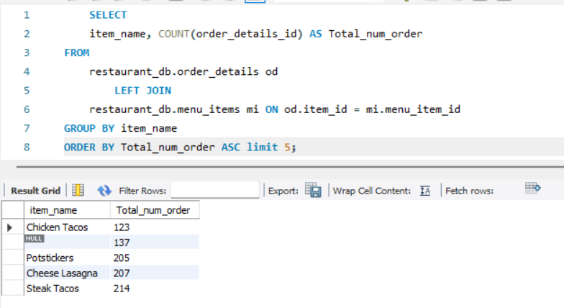

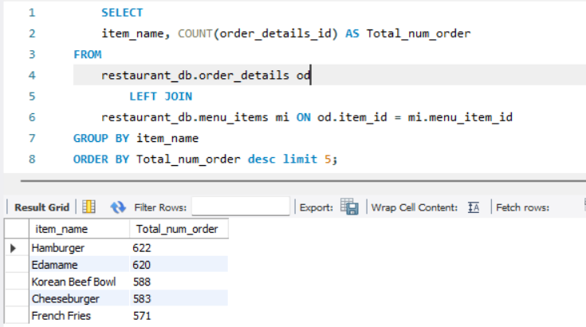

**-- Which are the most popular items by Category?**

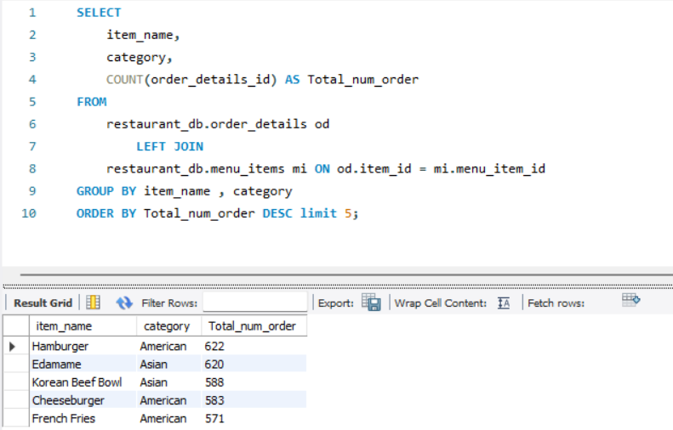

**-- Which are the least popular items by Category?**

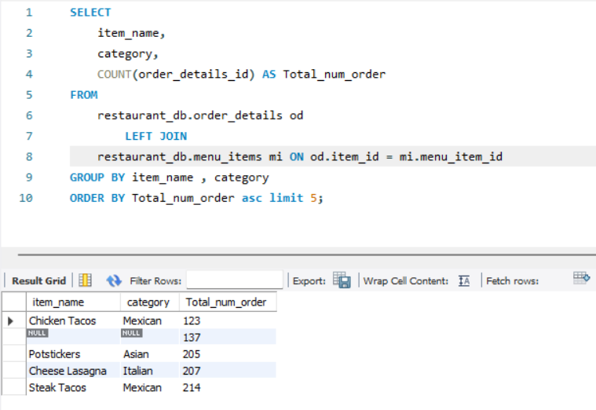

**-- What were the top five orders that spend the most money?**

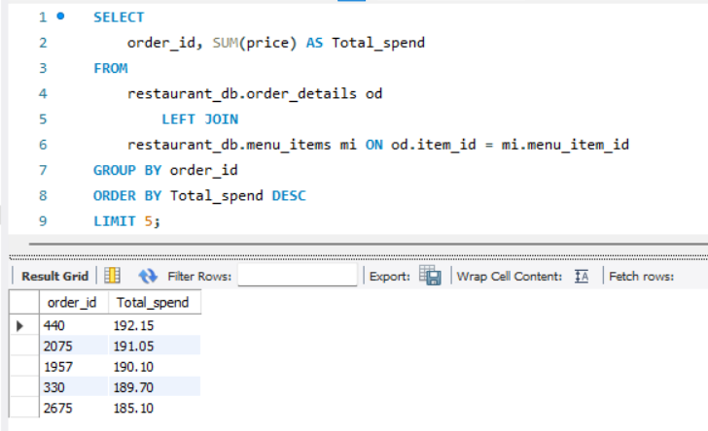

**-- View the detail of the highest spend order.**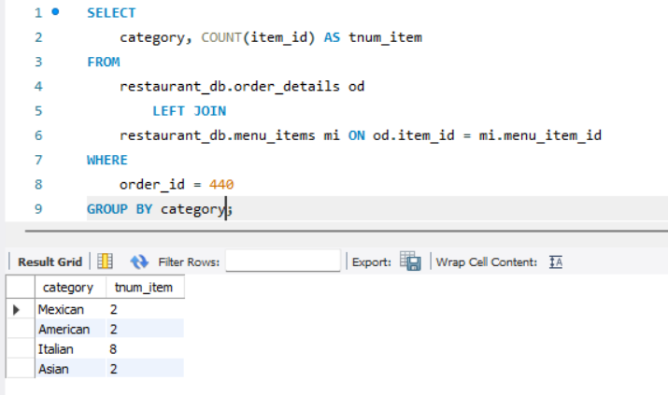

**-- View the detail of the highest spend order by Category.**

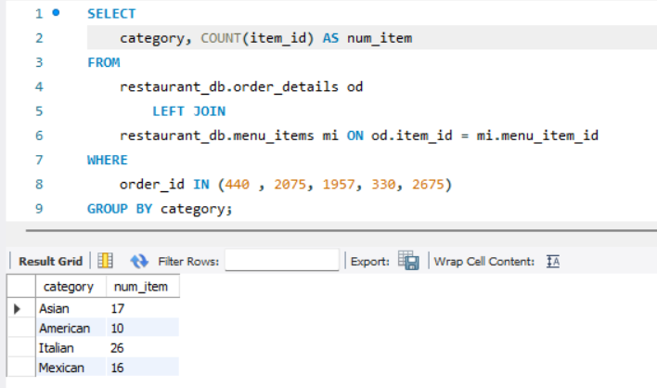

**-- View the detail of the highest spend order by Category and order_id.**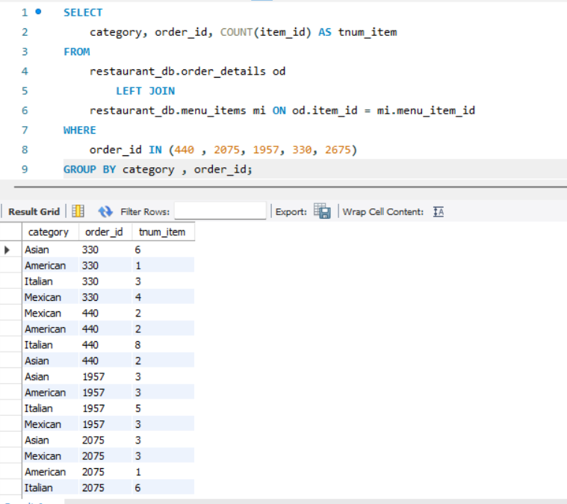

**Recommendation:**

1. Chicken Tacos is the least popular and should have to do something about it. I will suggest taking customer feed back about this product and take necessary action about it.
2. Hamburger and Edamame are the top two most popular items, so it should be on the list.
3. The most popular item by category is American and Asin. The least order item is the Mexican food. Some of the Mexican items are not doing well and to think about it.
4. The top five customer orders are most of the high spend order for the Italian food. I will recommend keeping expensive Italian dishes on the menu as people seems to be ordering lot specially the higher spend customer.